**PROJECT DEVELOPMENT PHASE**

**SPRINT-II**

|  |  |
| --- | --- |
| Date | 18 November 2022 |
| Team ID | PNT2022TMID45665 |
| Project Name | Natural Disaster Intensity Analysis and Classification using Artificial Intelligence |

***INSERTING NECESSARY LIBRARIES:***

**Numpy:** It is an open source numerical python library. **Scikit-learn:** It is a machine learning library for python.

**OpenCV:** OpenCV is a library of programming functions mainly aimed at real-time computer vision.

**Flask:** Web framework used for building web application.

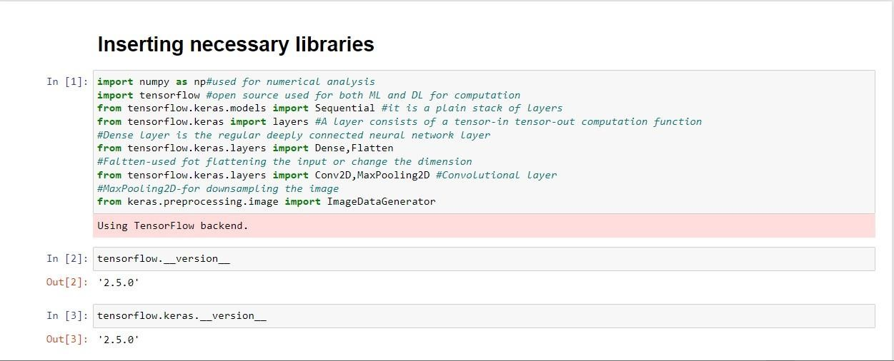

***LOADING DATA AND PERFORMING DATA AUGUMENTATION:***

Loading the data into the Jupyter notebook by using RR dataset path.

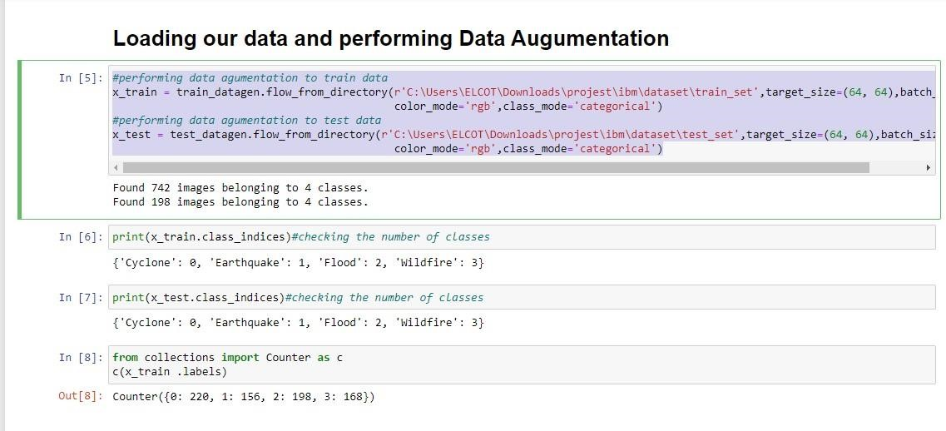

***CREATING THE MODEL:***

Creating the Model a Classifier Sequential. Classifier is a machine learning algorithm that determines the class of the input element based on the set of the feature. In this model using convolution2D function. Convolution2D parameter is an number of filters that convolution layer will be learn from. Then we will be using MaxPooling2D function. Then, using a Flatten() function that flatten the multidimensional input denser into the denser.

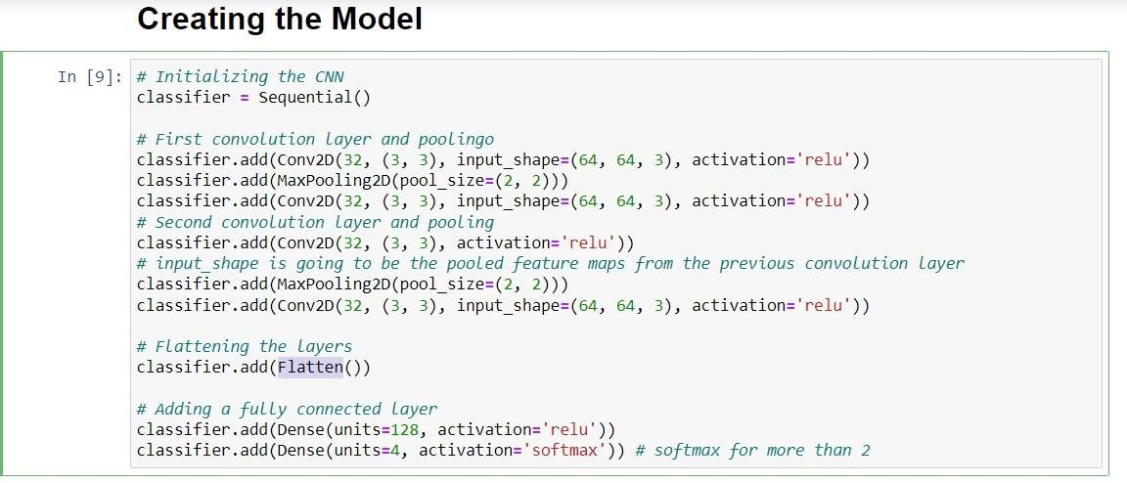

Using classifier.summary() function summary of our model

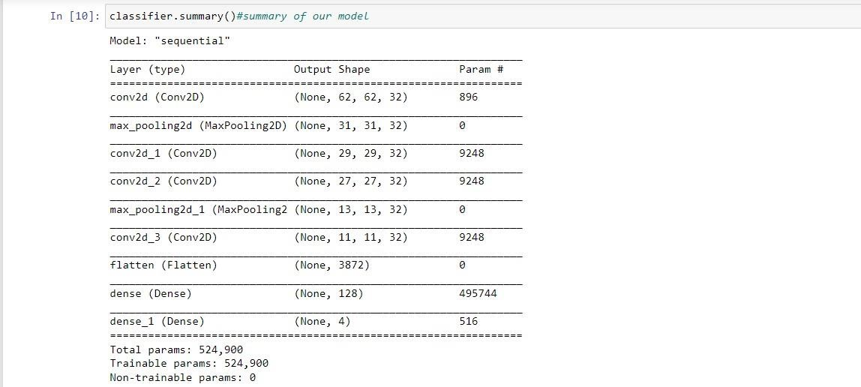

***COMPILING THE MODEL:***

The model is compiled using the following code.



***FITTING THE MODEL:***

Fitting the Model with 70 epoch.

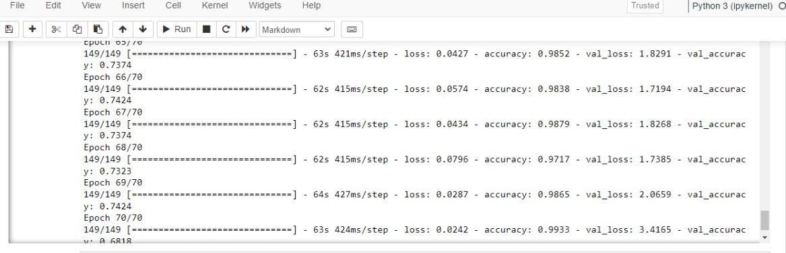

***SAVING THE MODEL:***

Saving the Model as disaster.h5. disaster.h5 file is used to find the image classification files. Model.json represents that Jason stands for JavaScript object rotation, Jason is a lite weight data format used for data inserting between multiple different language.

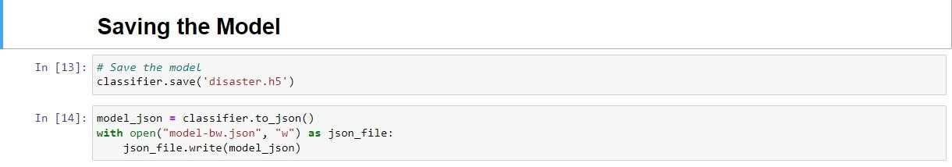

***PREDICTING RESULTS:***

Loading model from the tensorflow keras models and loading the image then converting image into array. Then predicting our model.

